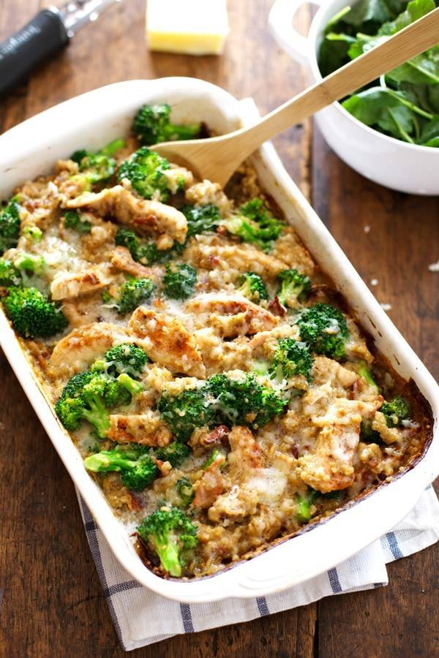

Creamy Chicken Quinoa and Broccoli Casserole
Ingredients:
- boneless skinless chicken breasts
- fresh broccoli florets
- quinoa
- gruyere cheese (any kind will work)
- chicken broth
- milk
- poultry seasoning
- flour
- crisp cooked bacon (optional… sort of)

- Grab Your Casserole Dish and Let’s Bake
- To achieve maximum velvety creamy goodness, and help everything reach its maximum texture potential, there are a few steps to bring it all together beyond, “Throw in dish. Bake.” Which is a very acceptable list of casserole instructions. But here we’re going to make a sauce, layer the ingredients, save the broccoli until the end to keep it bright and green and tender crisp.

Directions:
- Sauce: Bring the chicken broth and half the milk to a low boil in a saucepan. Whisk the rest of the milk with the poultry seasoning and flour and then add that in and whisk until a smooth creamy sauce forms.
- Assemble: Mix the sauce, one cup water, quinoa, and bacon (if using) in a bowl and pour that into the prepared baking dish. Slice the uncooked chicken breasts into thin strips and lay those right over the top of the quinoa mixture. Sprinkle with the seasoning.
- Broccoli: Go ahead and give that a quick steam and then set it aside until the last 10ish minutes of baking.
- Bake: Bake uncovered for about 30 minutes. Give it a check and a stir, and if needed, bake for an additional 10-15 minutes if needed to further thicken. Add that yummy broccoli and a little bit of water, stir until creamy and smooth. Top with the cheese and bake for 5 minutes, or just long enough to melt the cheese.

