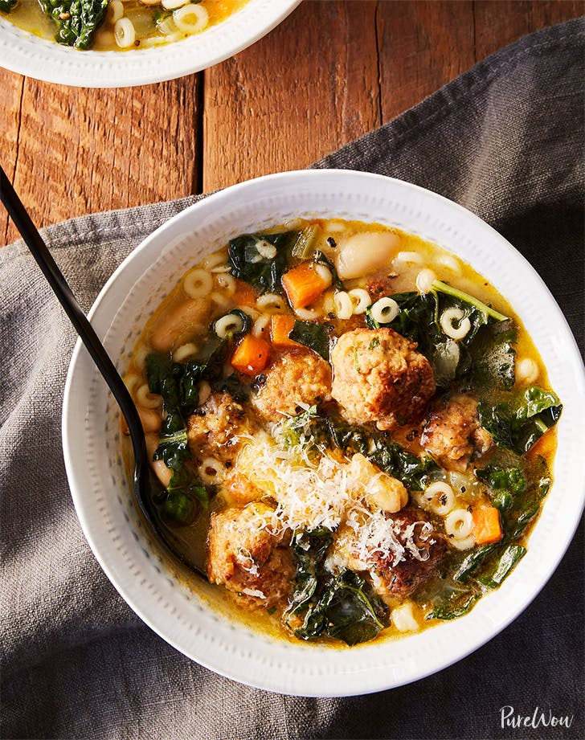

Cheater’s Italian Wedding Soup
Ingredients:
MEATBALLS
1-pound spicy Italian sausage, casings removed
¼ cup chopped fresh parsley
¼ cup grated Parmesan cheese
½ cup breadcrumbs
¾ teaspoon kosher salt
½ teaspoon freshly ground black pepper
2 tablespoons extra-virgin olive oil
SOUP
2 tablespoons extra-virgin olive oil
1 sweet onion, diced
3 carrots, peeled and diced
4 stalks celery, diced
3 garlic cloves, minced
6 cups chicken stock
1 bay leaf
1 cup short pasta, such as ditalini
One 14-ounce can white beans
1 bunch kale, deveined and sliced
½ cup grated Parmesan cheese, plus more for garnish
Kosher salt and freshly ground black pepper

Directions:
1. MAKE THE MEATBALLS: In a medium bowl, mix together the sausage, parsley, Parmesan, breadcrumbs, salt and pepper.
2. Using a tablespoon, form the mixture into bite-size balls, about 1 inch in diameter. Heat the olive oil in a large skillet over medium heat. Add the meatballs and cook until well browned on all sides, about 5 minutes. Transfer to a paper-towel-lined plate.
3. MAKE THE SOUP: In a large pot or Dutch oven, heat the olive oil over medium heat. Add the onion, carrots and celery; sauté until tender, 5 to 6 minutes. Add the garlic and sauté until fragrant, about 1 minute. Stir in the stock and bay leaf; bring to a simmer over medium-low heat. Simmer for 15 minutes.
4. Stir in the pasta and beans. Cook until the pasta is al dente, 6 to 8 minutes. Stir in the kale and the meatballs. Continue to simmer until the greens are wilted, about 5 minutes. Stir in the Parmesan and season to taste with salt and pepper before serving.

