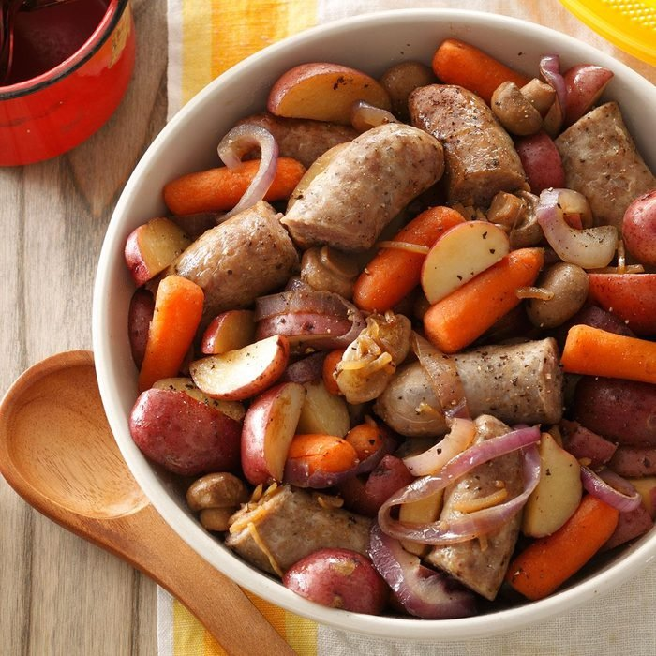

Bratwurst Supper

Ingredients
- 3 pounds uncooked bratwurst links
- 3 pounds small red potatoes, cut into wedges
- 1 pound baby carrots
- 1 large red onion, sliced and separated into rings
- 2 cans (4-1/2 ounces each) whole mushrooms, drained
- 1/4 cup butter, cubed
- 1 envelope onion soup mix
- 2 tablespoons soy sauce
- 1/2 teaspoon pepper

Directions- Baking
- Bake in oven covered for 1 hour at 350

Grilling
- For each of 2 foil packets, arrange a double thickness of heavy-duty foil (about 17x15 in.) on a flat surface.
- Cut brats into thirds. Divide the brats, potatoes, carrots, onion and mushrooms evenly between the 2 double-layer foil rectangles. Dot with butter. Sprinkle with soup mix, soy sauce and pepper. Bring edges of foil together; crimp to seal, forming 2 large packets. Seal tightly; turn to coat.
- Grill, covered, over medium heat for 23-28 minutes on each side or until vegetables are tender and sausage is no longer pink. Open foil carefully to allow steam to escape.

