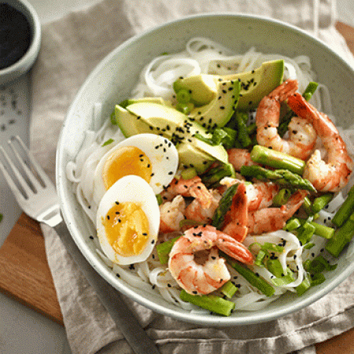

Garlic Shrimp and Asparagus Noodle Bowl

INGREDIENTS

Dressing
- ½ cup rice wine vinegar or rice vinegar
- ¼ cup toasted or regular sesame oil
- 1 zest of lime
- 3 tbsp fresh lime juice
- 2 tbsp mirin rice wine
- 2 tbsp less sodium soy sauce

Noodle Bowl
- ⅔ lb large black tiger shrimps, peeled and washed
- 12 asparagus spears, trimmed and cut into 1-inch (2.5 cm) pieces
- 3 cloves garlic, minced
- 2 tbsp olive oil
- 1 zest of lemon
- 1 tbsp fresh lemon juice
- ¼ tsp EACH salt & pepper
- ½ pkg rice vermicelli noodles, prepared according to package directions
- 4 soft-cooked eggs, peeled and halved
- 1 avocado, peeled and sliced
- ½ cup sliced green onion
- black sesame seeds for garnish

- DESCRIPTION
- Try to resist this colourful bowl filled with sliced avocado, crispy asparagus, garlic shrimp and hard-cooked eggs. It’s an irresistible mix of veggies and proteins!
- Instructions
- Dressing: In a small bowl, whisk together rice wine vinegar, sesame oil, lime zest and juice, mirin and soy sauce; set aside.
- Noodle Bowl: In a medium bowl, coat shrimp and asparagus in garlic, olive oil, lemon zest and juice, salt and pepper. Heat a large skillet, over medium-high heat, add shrimp mixture and cook, stirring often, for 6 to 7 minutes or until shrimp are cooked.
- Divide cooked noodles, eggs, sliced avocado and shrimp mixture between four bowls. Sprinkle with green onions and black sesame seeds. Drizzle with dressing.
- Tip: You can substitute the mirin rice wine for 2 tbsp (30 mL) white wine and 1 tsp (5 mL) sugar.
- Brought to you by: Egg Farmers of Ontario

