Buffalo Chicken Fry Bread
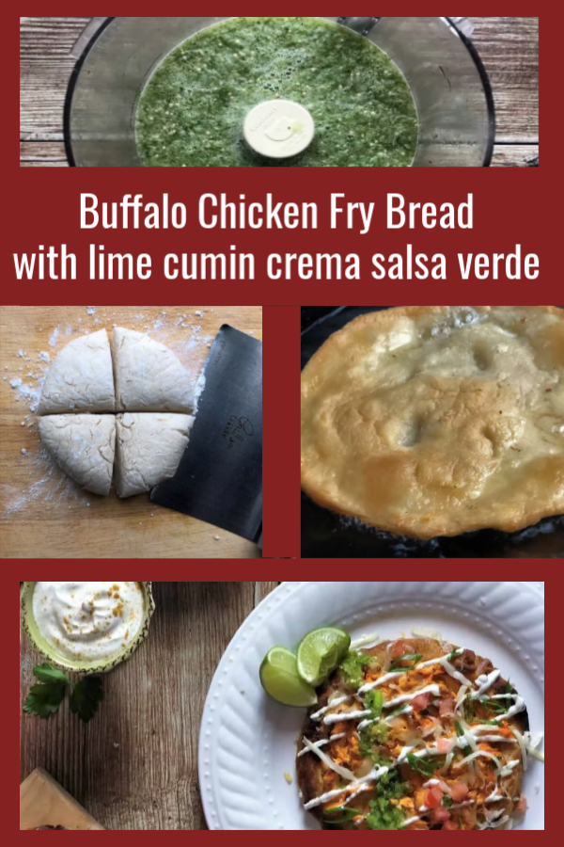

This Native American specialty is a flat dough known for being composed of very few ingredients. It’s rooted in culture, and the exact preparation varies depending on the region and tribe. Some are made with yeast and cornmeal, while others (like the one I’ll walk you through in this post) require no rising time and are purely made up of flour, baking powder, salt, and fat.
To enhance this dish with even more Native flair to sit atop our tasty fry bread base, I spike sour cream with smoky cumin. For a Mexican twist (these are tacos, after all): a raw, garlicky tomatillo salsa bursting with jalapenos, citrus, and cilantro.
Ingredients
1 1/2 cups all-purpose flour, plus additional for dusting and rolling out the dough
1 1/2 teaspoons baking powder
1/2 teaspoon salt
2 tablespoons unsalted butter, melted
3/4 cup water
1/2 cup buffalo sauce (store-bought or homemade)
1/4 cup cream cheese, softened
3/4 cup shredded Monterey Jack cheese, divided
2 cups shredded chicken breast (either homemade or from a rotisserie chicken)
4 tablespoons thinly sliced green onions, light green and white parts only, divided
1/2 cup sour cream
2 tablespoons half-and-half
2 limes, divided (plus additional lime wedges for serving)
1/8 teaspoon ground cumin
1/2-pound tomatillos, husked, rinsed and quartered
1/4 cup rough chopped fresh cilantro, plus more for garnish
1 small jalapeño, stemmed and chopped
1 large garlic clove, chopped
Vegetable oil (for frying, enough to reach 1-inch depth)
2 small Roma tomatoes, chopped
Instructions
Step 1 – Make and Rest the Fry Bread Dough
Melt the butter.
In the bowl of a stand mixer fitted with the dough hook attachment, add the flour, baking powder, and 1/2 teaspoon of the salt and mix on low speed to combine. Slowly pour in the butter and then the water (scraping the flour down from the sides of the bowl), a few tablespoons at a time, until the dough holds together and forms a ball, about 1-2 minutes. The dough will be sticky.
Using flour on your hands, if necessary, turn the dough out onto a piece of plastic wrap. Wrap tightly, and rest at room temperature for at least 30 minutes or at best, 1 hour.
Step 2 – Prepare the Toppings
Soften the cream cheese, thinly slice the green onions, juice both the limes and zest 1, rinse and quarter the tomatillos, and chop the cilantro, jalapeno, garlic, tomatoes, and remaining lime wedges. In a large bowl, mix together the buffalo sauce, cream cheese, 1/4 cup of the Monterey Jack cheese, shredded chicken, and 2 tablespoons of the green onions. Toss until the chicken is thoroughly coated in the sauce. Season to taste with additional salt.
In a small bowl, whisk together the sour cream, half-and-half, zest and juice of 1 lime, and the cumin. Season to taste with salt. In a food processor, pulse the juice of the additional 1 lime with the tomatillos, cilantro, jalapeno, garlic, and a pinch of salt until the salsa comes together. Season to taste with additional salt.
Step 3 – Divide and Flatten the Dough

Lightly flour a clean work surface. Unwrap the dough and divide it into 4 even pieces. Roll each piece into a ball and then, using the palm of your hand, stretch and flatten into 1/3-inch-thick rounds. The bread will puff up as they cook so you want them to be fairly thin. Pierce the center of each fry bread with a paring knife. This keeps the dough from over-bubbling during frying.
Step 4 – Fry the Dough
In a deep, wide cast-iron skillet or heavy-bottomed saucepan over medium-high heat, heat about 1 inch of oil to 350° F. If you don’t have a thermometer, you can test if the oil is hot enough by dipping the handle of a wooden spoon into it. If it bubbles steadily, the oil is hot enough. If it bubbles and sizzles vigorously, the oil is too hot.
Prepare a paper towel-lined plate next to the pan with the oil. Working in batches so you don’t crowd the pan, slide the dough rounds into the oil and fry until golden-brown, about 1-2 minutes per side. The dough will puff up and harden as it cooks.
Place the finished fry bread on the paper towel-lined plate to soak up any excess oil and immediately sprinkle them with salt.
Step 5 – Melt the Buffalo Chicken Mixture, Garnish, and Serve
Place an oven rack about 8-inches from the broiler and preheat the broiler to low.
Transfer the fry breads to a baking sheet lined with parchment paper and top with even portions of the buffalo chicken mixture. Broil until the bubbly and then divide among plates.

