Wild Rice Hamburgers
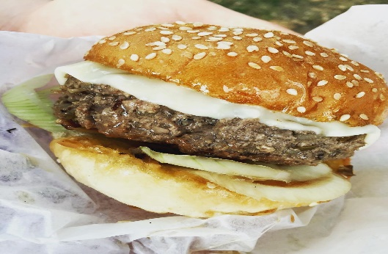

Ingredients
1 pound ground beef or substitute with 1 lb ground moose mixed with1 lb ground pork
2 cups cooked wild rice
2 cloves minced garlic (optional)
1 tablespoon fresh chopped or dried thyme, oregano, and/or rosemary (optional)
Salt and pepper to taste (optional)

Directions
Thoroughly mix the wild rice, ground meat of your choice and optional ingredients, if desired, in a large bowl until the texture is consistent.

Form into patties and grill or cook, and then serve like a standard hamburger on a sesame seed or onion bun.

