Whole Fish in Paperbark

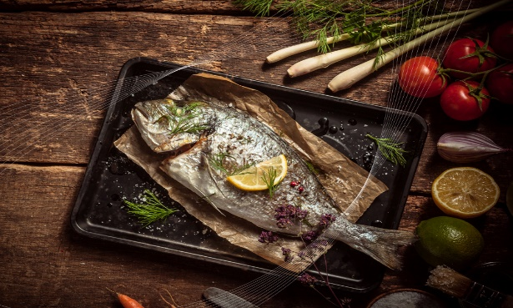
This recipe is a whole Fish in Paperbark which combines traditional Indigenous ingredients with a modern twist. Curiously, the Melaleuca paperbark was used to treat headaches and colds. In this recipe, it will add a delightful smoky flavour to your favourite fish. View the entire recipe below.

Ingredients
- • 1 sheet of melaleuca paperbark
- • 30ml olive oil OR lemon myrtle olive oil
- • Your favourite whole fish OR 250g fresh fish fillet
- • 2 tsp lemon myrtle
- • 20g native thyme
- • 30g butter
- • 1 lime
- • 1 lemon
- • Cooking twine
- • Foil – optional

Directions
Step 1
Prepare the paperbark by plunging into cold water. Dampen and squeeze out excess water.
If you cannot find paperbark, use baking paper.
Step 2
Brush oil onto the paperbark, then sprinkle a generous amount of lemon myrtle onto the paperbark. 1 -2 teaspoons.
Step 3
Place fish fillet onto the paperbark placing the knob of butter on top, sprinkle on the Lemon Myrtle & native thyme and lay a slice of lime and lemon over the fillet. If using whole fish, place lemon myrtle, native thyme and slices of lime & lemon inside the fish.
Step 4
Close the fish in the paperbark by tying the ends with the cooking twine.
Step 5
Wrap the fish in aluminium foil and cook on a BBQ top on a low heat for 10 minutes each side OR cook over hot coals.
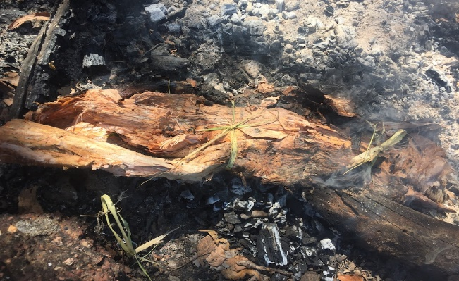

Serve with chips, salad and lemon wedges

