Traditional Algonquin Smoking Method for Meat and Vegetables

Cezin Nottaway is a young lady who learned traditional techniques growing up with her grandmother in the remote community of Red Lake, Que. Later she followed her dream of becoming a chef and graduated from Algonquin College in Ottawa.

She says cooking meat in tea gives it an earthy taste that's hard to describe.
"My grandma's [recipe] is tea and onions, that's how she'd cook her meat."
When smoking meat, Cezin Nottaway uses a family technique called piigidosiig.
Firstly, you must gather piigidosiig which is rotten wood that is used to smoke meat, vegetables and even cheesecake.
"It's just so homey, and it reminds me of my kokum’s. It tastes like deliciousness," said Cezin Nottaway.
"You make a fire, and you get the coals nice and hot, and you'd use this wet wood that you have just picked, and that's what you'd cover your red coals with," said Nottaway.
"With that you get this amazing smoke coming from this piigidosiig."
Cezin Nottaway has used this unique technique to smoke everything from meat to tomatoes and even cheesecake. While cheesecake isn't the most traditional Algonquin food, Nottaway is convinced that's how her ancestors would have made it.
Cezin Nottaway still draws from for her company Wawatay Catering, which specializes in serving traditional Algonquin recipes with a modern twist.
Her menus incorporate a lot of wild meat, but she prepares them using modern techniques.

Cezin's Seared Moose Sirloin (2 lbs)

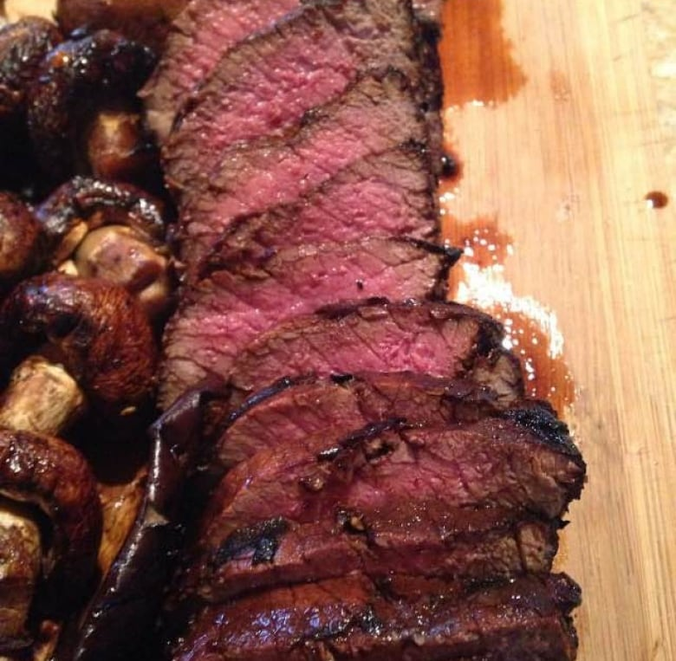

Cezin Nottaway's moose sirloin recipe is easy to follow.
1. Pre-heat oven to 375 F.
2. On medium high heat, prep your cast iron pan with butter.
3. Season sirloin with sea salt and freshly cracked pepper.
4. Once your butter is brown, sear all sides of the sirloin.
5. Pop it in the oven for 10 - 15 minutes, depending on how well done you like your meat.
6. Deglaze with a splash of red wine and finish with 1 tbsp of butter and a dash of maple syrup.
7. Serve with sautéed mushrooms

