The Hirshon Ojibwe-style Venison Stew

Jiibaakwaan Waashkesh

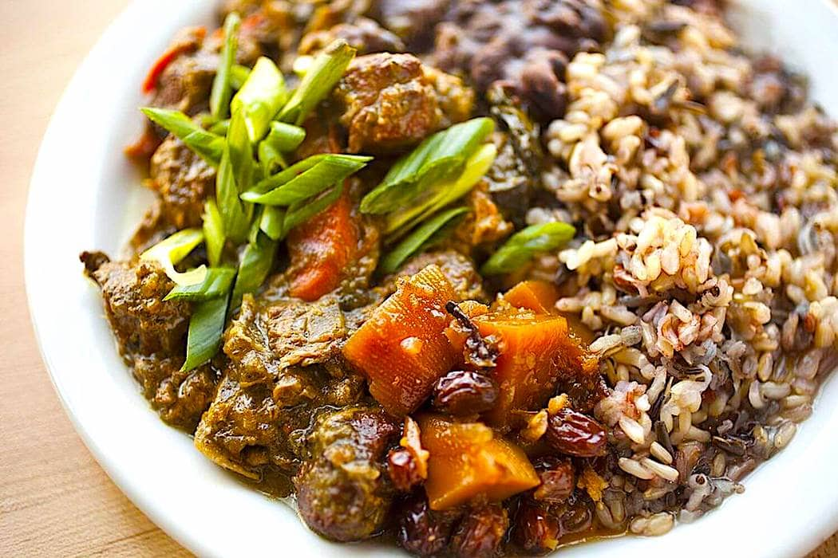

INGREDIENTS

- 1 1/2 lbs. venison stew meat, cubed into bite-sized pieces
- 1/8 cup lard or if you can get it, bear fat
- 1/8 cup corn oil
- 1 medium onion, coarsely chopped
- 3 scallions (green spring onions), chopped
- 1/3 cup minced heirloom orange squash
- Wild Ramp powder or chopped fresh ramps or wild onions to taste
- 1/2 cup shagbark hickory nuts, chopped coarsely
- 3 leafy celery stalks, de-stringed and diced, leaves included
- 1 fresh corn cob, kernels removed and cob reserved
- 1/2 cup wild rice
- 2 bay leaves
- 1 cup wild mushrooms, cut into bite-sized pieces
- 3 Tbsp. fresh parsley, chopped
- 1 Tbsp. minced fresh tarragon
- 1 1/4 tsp. freshly-ground juniper berries
- 1 1/4 tsp. coarse salt
- Tabasco to taste (obviously not traditional but delicious)
- 4 1/2 cups game or beef broth
- 1/4 cup acorn flour combined with 1/4 cup corn oil or lard in a hot pan until fragrant
- 1/4 cup maple syrup
- large pinch Filé powder

INSTRUCTIONS
- In a large cast-iron skillet or pot, heat oil and lard over medium-high heat. Add venison and brown on all sides.
- Add onions, scallions, mushrooms and corn, cook for another two minutes. Add remaining ingredients, including reserved corn cob (except Filé powder) blending and stirring well.
- Cover and cook for 30 minutes or until the meat, rice and vegetables are tender.
- Remove from heat, remove corn cob and bay leaves and add Filé powder and stir. Use enough Filé to give a thickened consistency to the stew.

