Sweetgrass Cherry Cake
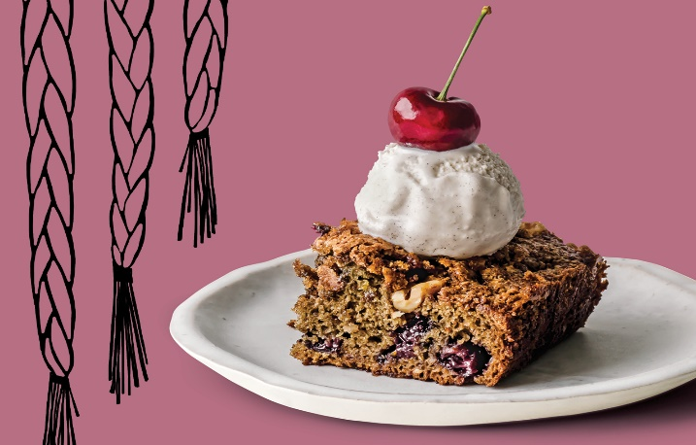
Inez Cook is the co-founder of Salmon n’ Bannock, a Vancouver bistro. This sweetgrass cherry cake recipe was inspired by Cook’s bittersweet history. She was one of many Indigenous children forcibly removed from their homes during the Sixties Scoop. Separated from her Nuxalk parents, she grew up eating mandarin orange cake with her adoptive family. She wanted to replicate the cake for her mother, who has Alzhemier's disease. Unable to find a recipe for that exact cake, she created this one. It has become her go-to whenever she needs an easy to make crowd-pleaser.

Ingredients
- 2 cups fresh or frozen pitted sweet cherries, such as Okanagan cherries
- 1 1/4 cups granulated sugar, divided
- 1 1-inch piece dried sweetgrass braid, placed in empty tea filter bag
- 1 1/2 cups all-purpose flour
- 1 tsp baking soda
- 1/4 tsp salt
- 1 large egg
- 1/2 cup packed brown sugar
- 1/2 cup walnuts

Instructions
- Position rack in centre of oven and preheat to 350F. Grease and flour an 8×8-in. baking pan.
- Combine cherries, ¼ cup granulated sugar and dried sweetgrass in a medium saucepan. Add enough water to just cover cherries. Bring to a boil over high. Reduce heat to medium-low and simmer for 1 hr.
- Place a sieve over a medium bowl. Drain cherries, reserving the cherry syrup for cake batter. Remove and discard dried sweetgrass. Cool cherry syrup slightly, about 20 min.
- Combine flour, baking soda, salt and remaining 1 cup granulated sugar in a large bowl. Whisk egg into cherry syrup. Add to flour mixture and stir until combined. Fold in cherries. Scrape batter into prepared pan.
- Combine ½ cup brown sugar and walnuts in a medium bowl. Sprinkle over batter.
- Bake until a cake tester inserted in centre comes out clean, 40 to 45 min. Transfer cake to a rack to cool slightly. Serve warm with whipped cream or vanilla ice cream.

