Succotash

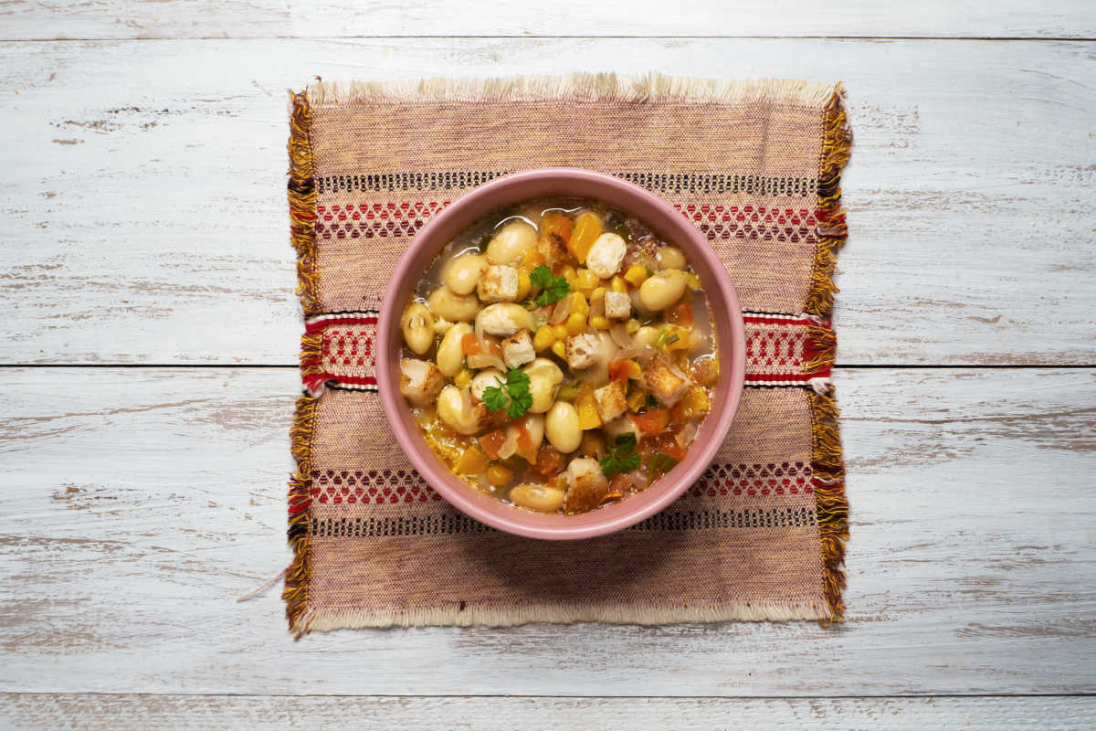
Tribes across the country enjoyed this super nutritious dish long before more folks relied on it as a cheap meal in the Great Depression.
Ingredients:
- 2 lbs. fresh or dry lima beans
- 3 cups fresh corn cut from cob
- 4 to 6 wild or pearl onions
- 2 Tbsps. melted bacon fat
- 2 pieces smoked ham hock
- 3 quarts water
- Salt and pepper to taste
Instructions: Soak dry beans for three to four hours to soften. Drain and add to a pot of boiling water. Let them cook for about 10 minutes, then add corn, ham hocks, salt and pepper, and onions.
Reduce the heat and cook on low for one hour.

