Saskatoon Berry and Brie Stuffed Chicken Breast Over Orzo Spinach Salad
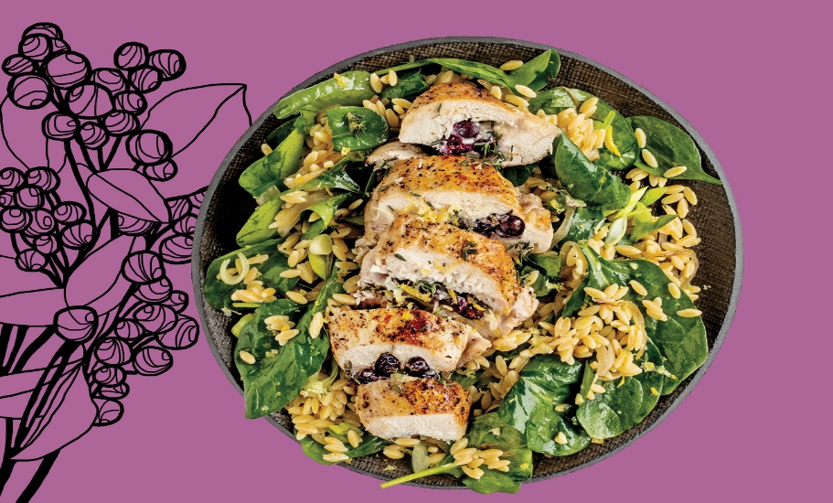
Christa Bruneau-Guenther is a home cook turned restaurant owner, of Feast Café Bistro in Winnipeg. She is Saulteaux Cree and French Metis from Peguis First Nation in Manitoba. Her stuffed chicken breast recipe is an “ode to the saskatoon berry,” a traditionally First Nations ingredient, while the brie is a nod to her French heritage.

Chicken
- 4 chicken breasts
- 1 tsp garlic powder
- 3/4 cup saskatoon berries
- 1 small wedge Brie cheese, rind removed, thinly sliced (about 113 to 170 g)
- 8 fresh thyme sprigs
- 2 tbsp olive oil

Orzo Salad
- 2 cups orzo (Using different types of rice is optional)
- 2 tbsp olive oil
- 1 medium onion, thinly sliced
- 2 cups baby spinach
- 4 green onions, thinly sliced

Dressing
- 5 tbsp olive oil
- 1 lemon, zested and juiced
- 1 tsp honey, (or agave or maple syrup)
- 1/2 tsp salt
- 1/4 tsp pepper

Instructions
- Position rack in centre of oven and preheat to 400F.
- Chicken: Pat each breast and dry with paper towels. Carefully slice through each breast horizontally, but not all the way through, leaving about ½ in. uncut on the opposite edge. It should open up like a book. Sprinkle with garlic powder. Season with salt and pepper. Divide saskatoon berries equally among bottom halves of breasts. Top with brie slices, then 2 thyme sprigs per breast. Fold top chicken flap over and press down firmly to enclose filling. Season both sides of chicken exterior with more salt and pepper.
- Heat a large cast iron pan (or any ovenproof pan) over medium high. When pan is hot, add 2 tbsp oil, then chicken, top-side down. Sear until bottom is browned, 2 to 3 min. Flip chicken over. Cook for 2 min more. Transfer chicken to a baking sheet.
- Bake until chicken is cooked through, about 20 min.
- Orzo Salad: Meanwhile, cook orzo or (Rice)according to package directions. Drain and rinse, and then transfer to a large bowl.
- Return cast iron pan to stovetop and set over low. Add 2 tbsp oil and onion. Cook, stirring often, until onion turns very brown, about 10 min. Add to cooked orzo, along with spinach and green onions.
- Dressing: Whisk 5 tbsp oil with lemon zest and juice, honey, ½ tsp salt and ¼ tsp pepper in a small bowl. Drizzle over salad. Toss to coat. Refrigerate until chicken is cooked.
- Remove stuffed chicken from oven. Let stand for 5 min before serving. Divide salad and chicken among 4 plates. Drizzle each breast with maple syrup, if desired.

