Rabbit and Dumplings
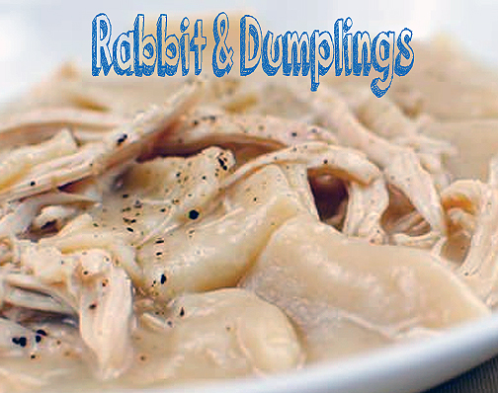
This recipe looks so appetizing. If you are a fan of chicken and dumplings, then you need to try it with rabbit.
INGREDIENTS:
For the rabbit:
4-5lb whole rabbit/s
1 medium-sized onion, chopped into large pieces
3 carrots, chopped into large pieces
3 celery stalks, chopped into large pieces
salt & pepper
For the dumplings:
2 cups all-purpose flour
1/2 teaspoon baking powder
pinch or 2 of salt
2 Tablespoons butter
1 cup milk

DIRECTIONS:
For the rabbit: Place rabbit, onion, carrots and celery into a very large soup or stock pot. Add enough water to cover the rabbit. Bring to a heavy boil, then lower the heat to a simmer. Place a lid on top and cook for an hour, flipping the rabbit halfway through. Carefully remove the rabbit to a plate.
Strain the rabbit broth through a large strainer lined with cheese cloth. Discard the vegetables and reserve 8 cups broth for the dish. Store the remaining broth in the refrigerator.
Remove meat off the rabbit and shred. Reserve 3 cups for the dish and store the remaining meat in the refrigerator.

For the dumplings: Combine flour, baking powder and salt in a large bowl. Cut the butter into the flour using a pastry blender, a fork, or your fingers. Add milk about 1/4 cup at a time, stirring between batches, until the dough comes together in a ball.
Working in batches, place the dough onto a heavily floured work surface. Flour a rolling pin, and roll the dough out thin. Don’t be afraid to keep adding more flour. If you don’t, the dough will stick to the board or counter. Using a pizza cutter, cut the dough into approximately 2″ x 2″ squares.
Flour a large plate or platter to place the dumplings on while you roll and cut out the rest of the dough. Generously sprinkle flour between each layer as you place them on the platter so they don’t stick together.

For the rest of the dish: Bring 8 cups rabbit broth to a boil and add dumplings in one at a time while gently stirring to prevent them from sticking together. Don’t worry about too much flour from the dumplings getting into the broth. The more that gets in there, the thicker the sauce will be.

Cook dumplings for 10-15 minutes, stirring occasionally and more often towards the end so they don’t stick to the bottom of the pot. When dumplings are cooked, turn off the heat and add in 3 cups shredded rabbit. Season with more salt & pepper to taste, and serve.

