Pork Roast

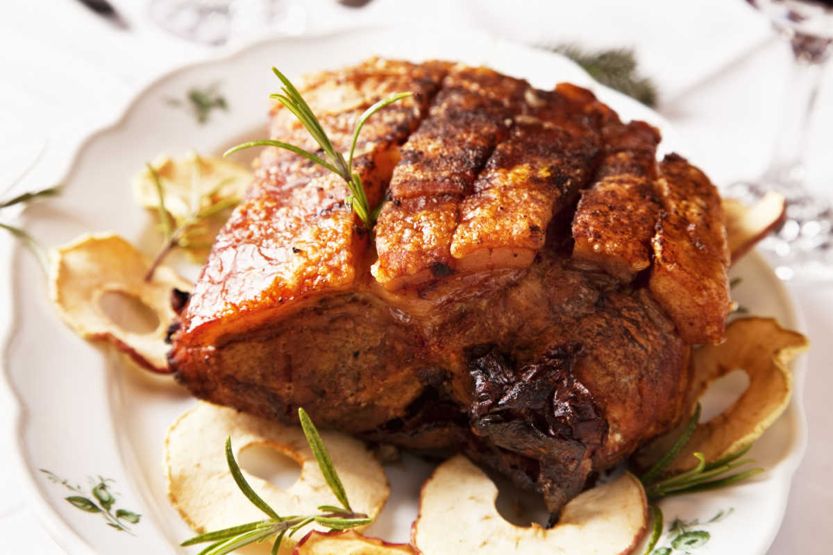
Pork has always been a favorite main dish for several tribes, but the Pueblo Indians in New Mexico gave it their own flavor with this recipe.
Ingredients:
1/4 cup vegetable oil
1 1/2 cups onions, chopped
3 minced garlic cloves
4 crushed and dried juniper berries
1/2 tsp. crushed coriander seed
1 bay leaf 4 large ripe tomatoes
1 1/4 cups water
2/3 cup cider vinegar
1/2 cup honey
1 Tbsp. ground red chili
1 medium-hot crushed dried chili
2 tsps. salt
1 oz. unsweetened chocolate square
5 lbs. pork rib roast
Instructions: Sauté onions in oil until they're soft, then add garlic, juniper berries, coriander seed, and bay leaf. Continue to sauté for a few more minutes. Quarter and seed your tomatoes, then add water, vinegar, honey, the ground and crushed chilies, and salt. Cover and allow to simmer for about 30 minutes.
Grate the chocolate and add, then allow to simmer uncovered for another 20 to 30 minutes until it becomes thick. Put the pork in a pan and baste with the sauce, then roast in the oven at 350 °F for about three hours, basting every now and then as it cooks.

