Pine Nut Catfish

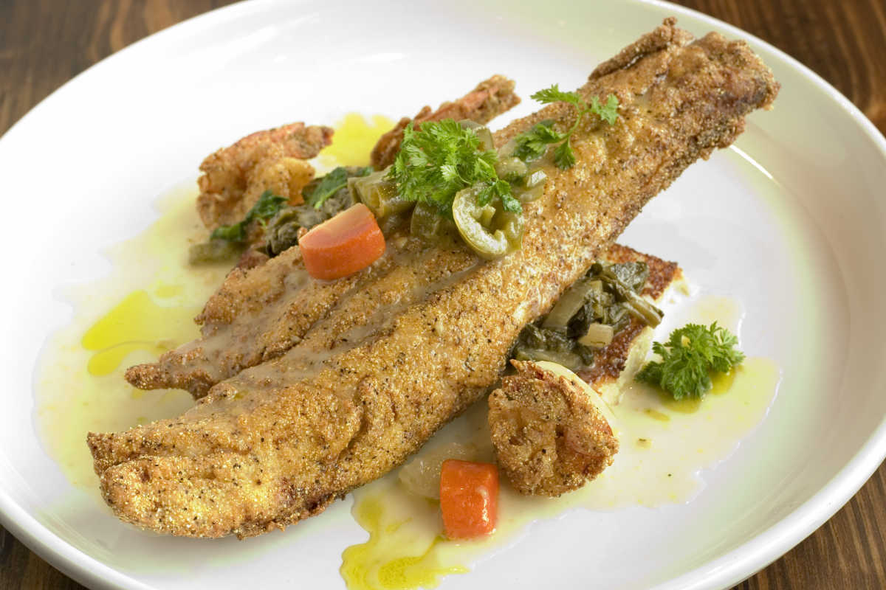
Tribes in the New Mexico region developed this nutty spin on fresh-caught catfish.
Ingredients:
- 1⁄4 cup pine nuts
- 2 additional Tbsps. pine nuts
- 1/2 cup yellow cornmeal
- 1/4 cup flour
- 1 tsp. salt
- 1/2 tsp. cayenne pepper
- 1/4 tsp. ground cumin
- 4 catfish fillets
- 1/4 cup vegetable oil
Instructions: Preheat your oven to 350 °F. Spread pine nuts in an even layer on a baking sheet and toast for about five minutes or until brown. Set aside to cool, then grind 1/4 cup of them and leave the rest for garnish later.
Mix the ground pine nuts, cornmeal, flour, salt, cayenne pepper, and cumin, and coat your fillets. Heat the oil in a large skillet and fry the fish for about four minutes on each side. Sprinkle with the leftover toasted pine nuts before serving.

