Pemmican

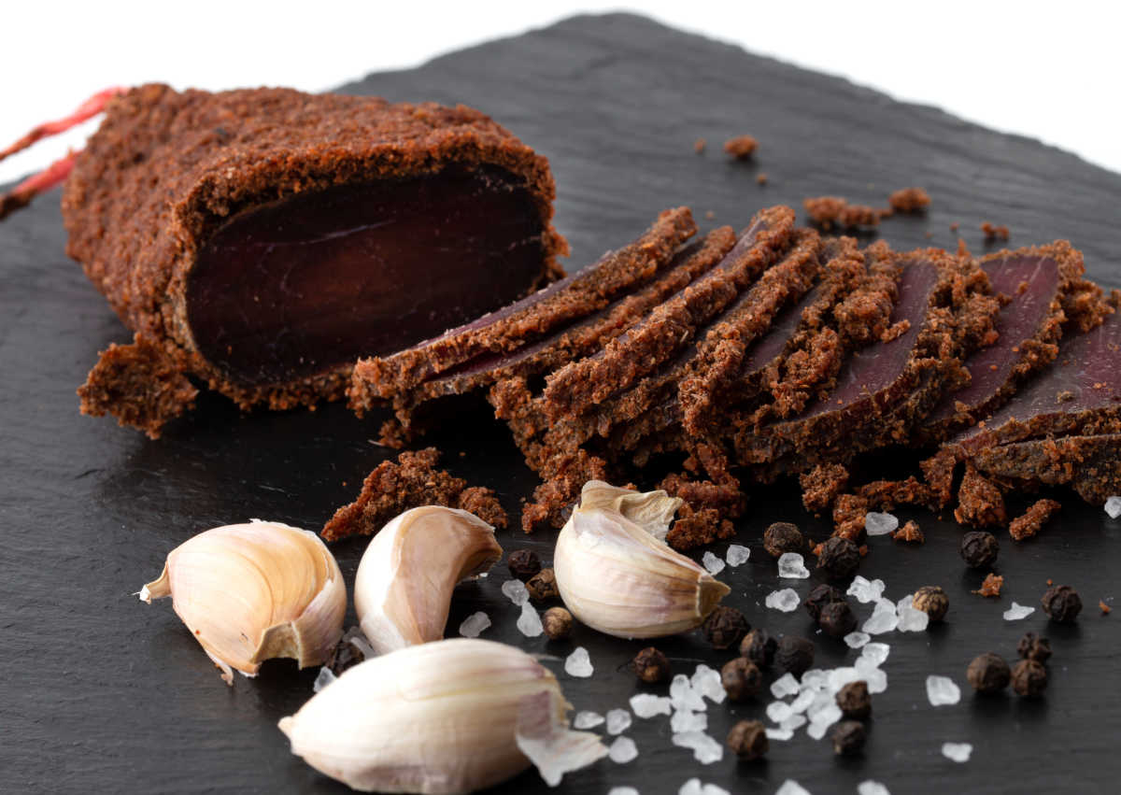
Though the name comes from the Cree Nation, many Native Americans have used this classic recipe to keep their energy up on long journeys.
Ingredients:
- 4 cups lean meat
- 3 cups dried fruit
- 2 cups rendered fat
- Unsalted nuts
- Dash of honey
Instructions: Lean meat can be deer, beef, caribou or moose. Spread whichever you have available out on a cookie sheet and dry in the oven at 180 °F for at least eight hours, or until crispy. Once it's cooled, pound it into a powder-like consistency and grind the dry fruit.
Heat the rendered fat until it becomes a liquid, then pour over the dried meat and fruit and mix in the nuts and honey as well. Mix and slice into portions, then store in a cool, dry place.

