Meat Loaf Made with Moose & Pork
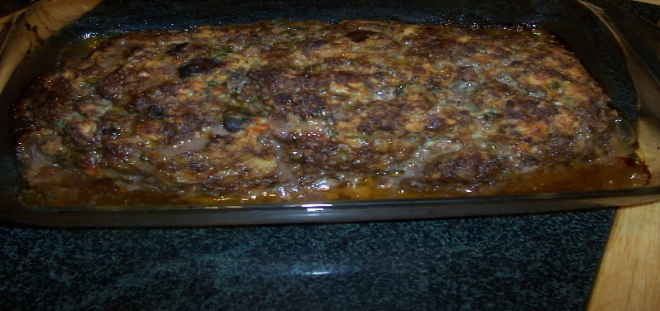
Ingredients:
1 Lb ground moose
1 lb ground pork
1 medium onion
1 egg beaten
1 Can Tomato Soup (Optional)
Salt and pepper to taste
Pinch or two of garlic powder
Sprinkle of parsley
Sprinkle of Panko Crumbs (Just enough to hold mixture together)

Directions:
Combine all ingredients in a large bowl, mix thoroughly with hands.
Place and press mixture in a loaf pan or a medium size glass casserole dish.
Bake at 350 degrees for 1 hour. (Time may vary due to various oven temperatures.)
Cut into 1” slabs – this meat loaf can be eaten plain or topped with your favorite gravy or ketchup; this will be your preference. The leftover meat loaf is very tasty on a sandwich made with homemade bread fresh out of the oven.

