Grilled Salmon Sandwiches
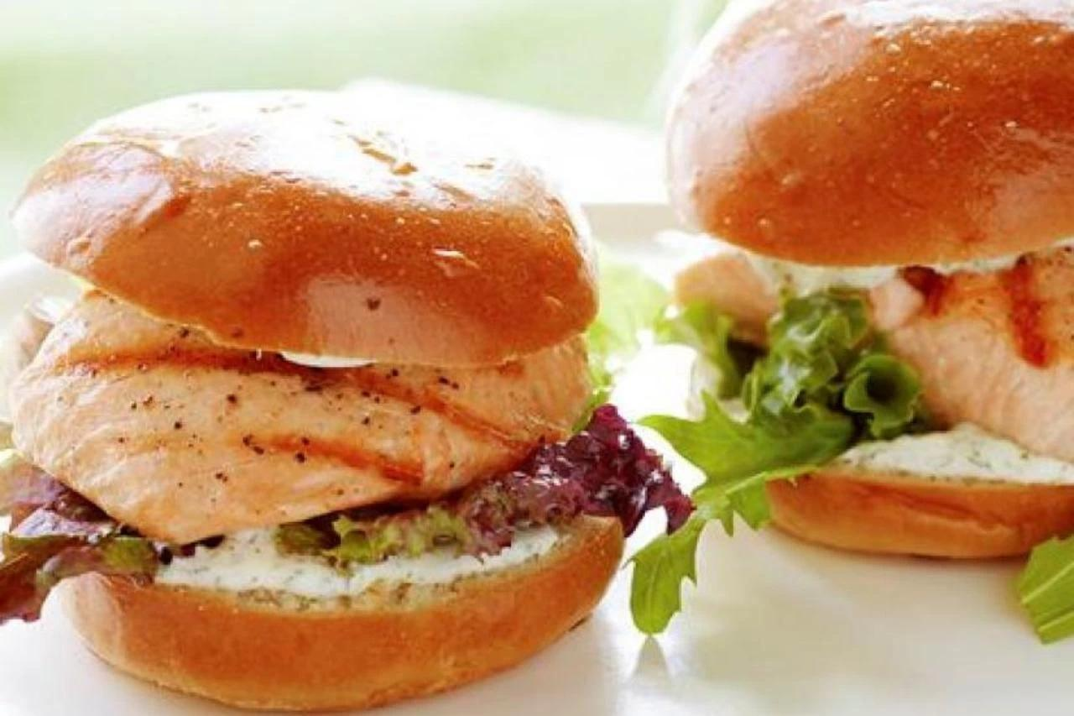

INGREDIENTS

Sandwiches
2 lb(s) fresh salmon fillets
Olive oil
Kosher salt
Freshly ground pepper

For the sauce
1 cup mayonnaise
¼ cup sour cream
¾ tsp white wine vinegar
12 fresh basil leaves
¾ cup fresh chopped dill
1 ½ tbsp chopped scallions (white and green parts)
¼ tsp kosher salt
¼ tsp freshly ground black pepper
3 tsp capers, drained

To assemble
6 fresh white or brioche rolls (4-inch round)
¼ lb(s) mesclun mix or fresh basil leaves

DIRECTIONS
Step 1
For the salmon, heat coals in an outdoor grill and brush the top of the grill with oil. Rub the outside of the salmon with olive oil, salt, and pepper, to taste. Grill for 5 minutes on each side, or until the salmon is almost cooked through. Remove to a plate and allow it to rest for 15 minutes.
Step 2
For the sauce, place the mayonnaise, sour cream, vinegar, basil, dill, scallions, salt, and pepper in the bowl of a food processor fitted with a steel blade. Process until combined. Add the capers and pulse 2 or 3 times.
Step 3
To assemble the sandwiches, slice the rolls in 1/2 crosswise. Spread a tablespoon of sauce on each cut side. On the bottom 1/2, place some mesclun salad and then a piece of salmon. Place the top of the roll on the salmon and serve immediately.

