Easy Fish Tacos
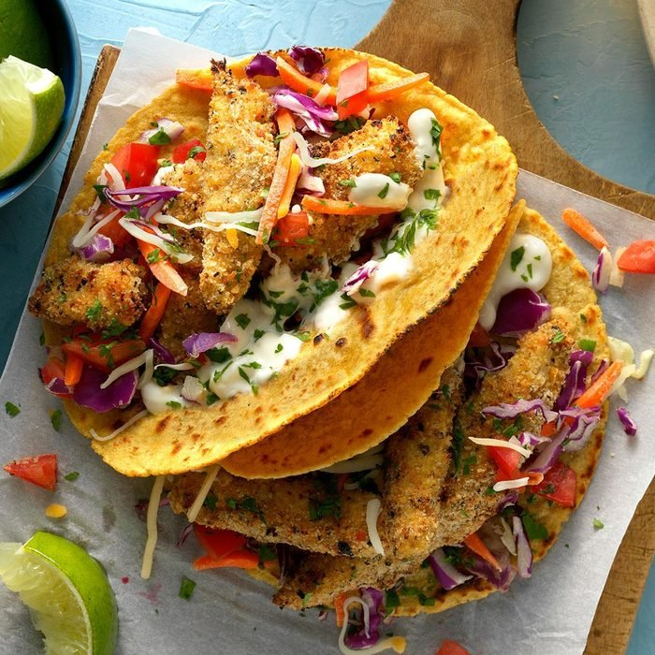

Ingredients
1/2 cup mayonnaise
1 tablespoon lime juice
2 teaspoons milk
1 large egg
1 teaspoon water
1/3 cup dry bread crumbs
2 tablespoons lemon-pepper seasoning, add salt to taste
1-pound mahi mahi or cod fillets, or any fish of your preference cut into 1-inch strips
4 corn tortillas (6 inches), warmed

Toppings:
1 cup coleslaw mix
2 medium tomatoes, chopped
1 cup shredded Mexican cheese blend
1 tablespoon minced fresh cilantro

Directions
- For sauce, in a small bowl, mix mayonnaise, lime juice and milk; refrigerate until serving.
- In a shallow bowl, whisk together egg and water. In another shallow bowl, toss bread crumbs with lemon pepper. Dip fish in egg mixture, then in crumb mixture, patting to help coating adhere.
- Place a large non-stick skillet over medium-high heat. Add fish; cook 2-4 minutes per side or until golden brown and/or flakes easily with a fork. Serve in tortillas with toppings and sauce.
- For an added touch, squeeze some lime or lemon juice on these tacos before you dig in!

