Crispy Potato Flake Pickerel With Tartar Sauce
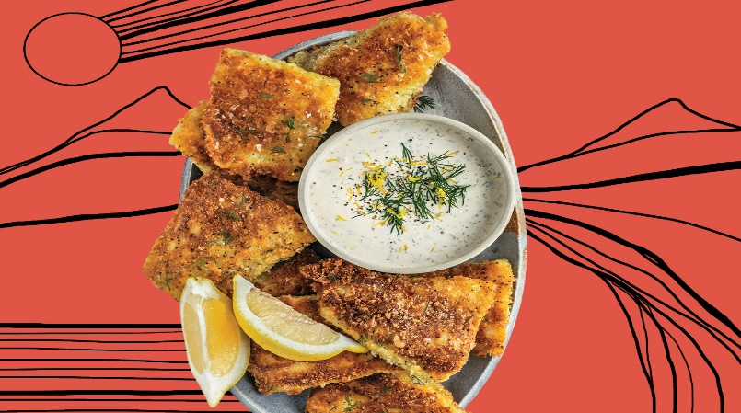
Kirsten Buck grew up on Tataskweyak Cree Nation (Split Lake) and in The Pas, in northern Manitoba. She published her first cookbook, Buck Naked Kitchen, last year. The inspiration for her recipe is childhood memories of her cho-chum (grandpa) making a midnight snack of fried pickerel.

Tartar sauce
- 3/4 cup mayonnaise
- 1 1/2 tbsp lemon juice
- 1 tbsp Dijon mustard
- 1 tsp coconut aminos, (see Kitchen Tip)
- 2 tbsp finely chopped dill pickles
- 1 tbsp capers, finely chopped
- 1 tbsp minced red onion, or shallot
- 1 tsp dried dill

Fish
- 680 g fresh pickerel, fillets, bones removed
- 3 tbsp arrowroot starch
- 2 tsp curry powder
- 1/4 tsp cayenne pepper, (optional)
- 1 large egg
- 3/4 cup potato flakes, such as Bob’s Red Mill
- 1/2 tsp salt
- 1/4 tsp pepper
- avocado oil, for frying
- lemon wedges, for serving

Instructions
- Tartar Sauce: Whisk mayo with lemon juice, Dijon and coconut aminos in a medium bowl until smooth. Stir in pickles, capers, onion and dill. Season with salt and pepper. Cover and refrigerate until ready to serve.
- Fish: Pat fish dry with paper towels. Cut each fillet into 3 smaller-sized pieces. Season lightly with salt and pepper.
- Line a large plate with parchment. Combine arrowroot starch, curry powder and cayenne in a shallow bowl. Whisk egg in a second shallow bowl. Combine potato flakes, ½ tsp salt and ¼ tsp pepper in a third shallow bowl.
- Working with 1 piece of fish at a time, dredge pieces in starch mixture, then shake off excess starch. Dip both sides into egg, then coat all over with potato flake mixture, pressing gently so it sticks. Transfer to prepared plate.
- Add enough oil to cover bottom of a large, shallow frying pan. Set over medium. When oil is hot, add a few pieces of fish to the pan (do not overcrowd; do this in 2 batches). Cook, flipping halfway, until fish is golden-brown and very crispy, about 1 to 2 min per side. (It may take
another minute for thicker pieces.)
- Transfer fish to a paper-towel-lined plate. Serve with tartar sauce and lemon wedges.

