Buffalo (Or Beef) Stew

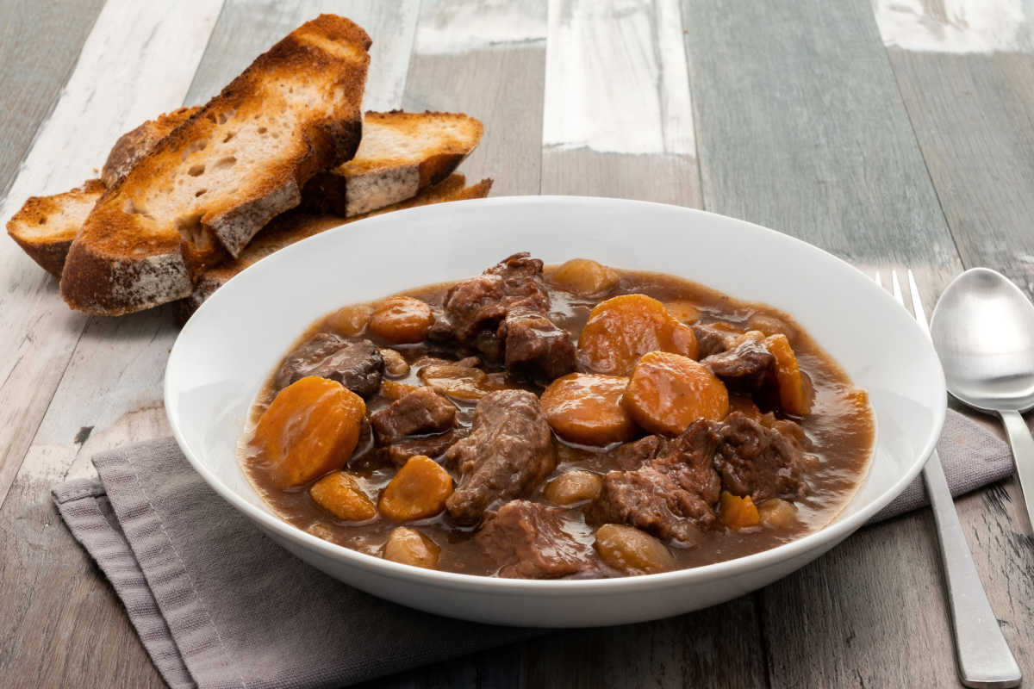
Known as tanka-me-a-lo in the Cherokee Nation, you can substitute regular beef if you're unable to find any buffalo meat in your area for this filling stew.
Ingredients:
- 2 stalks celery
- 2 carrots
- 1 can stewed tomatoes
- 2 lbs. buffalo/beef stew meat
- 4 quarts water
- 2 lbs. red or white potatoes (not russets)
- 1 cup barley
Instructions: Slice the carrots, celery, and meat into cubes about one inch long, then brown the buffalo over high heat for about three minutes. Add the water, potatoes, and carrots into a large pot and boil until tender.
Add in the tomatoes, barley, and celery, and let cook for another five minutes or so. Pour the veggies and meat into a baking dish and place in the oven at 425 °F for 30 minutes.

