Algonquin Bannock 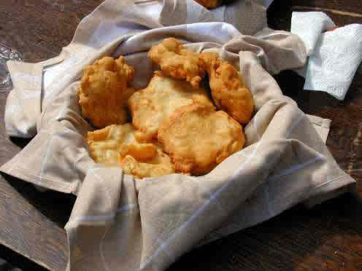

INGREDIENTS

2 cups flour (preferably fresh-ground)
¹⁄₄ teaspoon baking powder
¹⁄₄ teaspoon salt
water, enough to provide consistency (preferably from a lake or creek)
- Provided are two versions - fire cooked (preferred) and pan-cooked.
- Fire-cooked: First; if you're making this in camp, it's best to use natural tools. Locate a flat rock (slate is best, of course), sheet of birch bark or similar flat surface. You can use a bowl or a frypan but it's not as much fun. :) Next, find a Y-shaped stick about 2 feet in length; fairly stout - the branches should be about the width of your thumb and should be about two fist-widths apart.
- Pre-mix the dry ingredients prior to departure. Don't worry; the seemingly miniscule amounts of salt and baking powder are more than enough.
- Pour a small mound of dry mixture onto your flat surface; add water a few drops at a time until a thick dough is formed. Keep adding mixture and water until all mixture is used (or until you have enough. If you're wise, you'll carry a fairly large bag of mixture; enough for several days).
- Be careful - consistency is critical. The dough must be thick enough to braid. Add water slowly and add less than you think you need.
- Form dough into a ball and let it rise 10-15 minutes; use this to build up the fire to cooking temperature.
- Roll the dough into a 'Plasticene snake' about 2 inches across. Braid the snake around the ends of the Y-shaped stick tucking the ends in at the bottom. Then simply roast it in front of (not over) the fire, flipping every 1-2minutes until golden-brown. (If you hold it over the fire, you'll cook it too fast).
- Let cool for a few seconds and tear pieces off. Serve with butter, but it's better dipped into meat juice. In winter, dip into white bacon fat and roast until the fat is brown - good fuel at 30 degrees below zero.
- Pan-cooked: Exactly the same preparation except you may need to add more water until it forms a very thick batter - twice the thickness of pancake batter. Let rise for 10 minutes. Pour into frypan and cook slowly until golden brown. Serve as above.

Cast-iron Frying Pan Bannock Recipe
4 cups of flour
4 teaspoons baking powder
1 teaspoon salt
4 tablespoons cooking oil

Directions:
Mix ingredients and add water until you have a doughy consistency.
Cover the bottom of your cast-iron frying pan in oil and heat until very hot.
Break dough into small pieces and add to cast-iron frying pan.
Fry until golden brown, turning once (approximately 12-15mins)

Blueberry Bannock Recipe
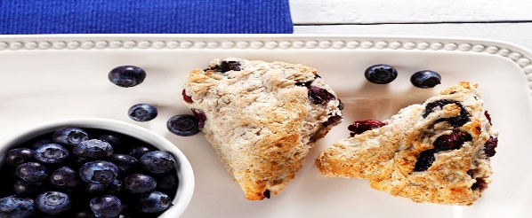
Minutes to Prepare: 5
Minutes to Cook: 30
Number of Servings: 12

Ingredients
3 cups all-purpose flour
1 tbsp baking powder
1 1/2 tsp salt
1 3/4 cups water
1 cup blueberries
1.5 tsp ground cinnamon

Directions
Mix the dry ingredients together, add the blueberries and stir. (If you want, you can leave out the baking powder and it won't rise, leaving you with a hard flat bread.) Add the water quickly and continue to stir.
Spread the batter on a pie plate and put in a preheated oven heated to 425Â°F. Bake for 20-40 minutes - check it at 20 minutes by sticking a fork in it. When it's done, there should be no dough on the fork.
Cut into about pieces and serve. Number of Servings: 12

